**Group Chat Analysis**

A PROJECT REPORT

***Submitted by***

      BL.EN.U4CSE19008 A.V.N.Rambabu

      BL.EN.U4CSE19064 K.Aditya Rohith

      BL.EN.U4CSE190103 P.Jaswanth Sai Reddy

BL.EN.U4CSE19046 G.Bala Nagendra Babu

***in partial fulfillment for the award of the degree of***

**BACHELOR OF TECHNOLOGY**

IN

COMPUTER SCIENCE AND ENGINEERING



AMRITA SCHOOL OF ENGINEERING, BANGALORE

 AMRITA VISHWA VIDYAPEETHAM

BANGALORE 560 035

May – 2022

**AMRITA VISHWA VIDYAPEETHAM**

**AMRITA SCHOOL OF ENGINEERING, BANGALORE, 560035**



**BONAFIDE CERTIFICATE**

This is to certify that the project report entitled **“Group Chat Analysis”**submitted by

BL.EN.U4CSE19008 A.V.N.Rambabu

      BL.EN.U4CSE19064 K.Aditya Rohith

      BL.EN.U4CSE190103 P.Jaswanth Sai Reddy

BL.EN.U4CSE19046 G.Bala Nagendra Babu

in partial fulfillment of the requirements for the award of the **Degree Bachelor of Technology** in “**COMPUTER SCIENCE** **AND** **ENGINEERING**” is a bonafide record of the work carried out under my guidance and supervision at Amrita School of Engineering, Bangalore.

Ms.Kavitha C.RDr.Amudha J.Dr. Sriram Devanathan

Assis. ProfessorProfessorProfessor and Chairperson,

Dept. of CSE Dept. of CSE Dept. of CSE

This project report was evaluated by us on 20/05/2022

**ACKNOWLEDGEMENT**

The satisfaction that accompanies successful completion of any task would be incomplete without mention of people who made it possible, and whose constant encouragement and guidance have been source of inspiration throughout the course of this project work.

We offer our sincere pranams at the lotus feet of **”AMMA”,** **MATA AMRITANANDAMAYI DEVI** who showered her blessing upon us throughout the course of this project work.

We owe our gratitude to **Br. Viswamrita Chaitanya Swamiji**, Director, Amrita School of Engineering, Bangalore.

We thank **Dr. Sriram Devanathan,** Principal and Chairperson-CSE, Amrita School of Engineering, Bangalore for his support and inspiration.

It is a great pleasure to express our gratitude and indebtedness to our project guide **GUIDE NAME AND DESIGNATION**, Department of Computer Science and Engineering, Amrita School of Engineering, Bangalore for her/his valuable guidance, encouragement, moral support, and affection throughout the project work.

We would like to thank express our gratitude to project panel members for their suggestions, encouragement, and moral support during the process of project work and all faculty members for their academic support. Finally, we are forever grateful to our parents, who have loved, supported and encouraged us in all our endeavors.

**ABSTRACT**

WhatsApp Analyzer means we are analyzing our WhatsApp group activities. It tracks our conversation and analyses how much time we are spending or saying it as “wasting” on WhatsApp. The aim of this article is to provide step by step guide to build our own WhatsApp analyzer using python. Here we used different python libraries which help me to extract useful information from raw data. .

**TABLE OF CONTENTS**

**Page no**

ACKNOWLEDGEMENT i

ABSTRACT ii

LIST OF FIGURES iv or v

LIST OF TABLES vi

CHAPTER 1- INTRODUCTION 1

* 1. INTRODUCTION TO SALESFORCE 1
  2. MOTIVATION 2

CHAPTER 2 – LITERATURE SURVEY 3

CHAPTER 3 – DESIGN 4

CHAPTER 4 – REQUIREMENTS AND ANALYSIS 5

4.1 SOFTWARE REQUIREMENTS

CHAPTER 5 – IMPLEMENTATION 6-9

CHAPTER 6 – TESTING 10-14

CHAPTER 7 – RESULTS 13-16

CHAPTER 8 – CONCLUSION AND FUTURE SCOPE 17-22

REFERENCES 23

**CHAPTER - 1**

**INTRODUCTION**

**1.1 Introduction**

* These days, the use of social media networks now have become a commonplace mode of data sharing.
* People using social media for personal purpose and also used for the professional purpose as sharing or advertising the business-related details etc.
* For the privacy and safety of the users the data is encrypted.
* We analyze the model and we can conclude whether the chat we are going safe and going correctly or not and also we can get the review of the group chat.

**1.2 Motivation**

* This Group Chat Analysis work is intended to perform an activity analysis and time analysis.
* This analysis has many use instances just like the parent, who wants to analyze their child chat, the police , who need to get valuable data from culprit chat , and the business people, who wants to understand the status of the business in the group chat.
* This enables to find the state of mind of the users. Further, this analysis work calculates the number of positive and negative statements which are used by everybody within the group chat.
* The motivation for this group chat analysis goes deep as we can retrieve the following information .
* Number of messages per user.
* Number of words per user.
* Number of average words per message per user.
* Number of Media per user.
* Number of messages per hour, week, month.

**CHAPTER - 2**

|  |  |  |  |  |
| --- | --- | --- | --- | --- |
| S.NO | Name of the author | Full title of the paper | Inference of the paper | Open problem |
| 1 | Ravishankar , Dhanush | Whatsapp Chat Analyzer | FDS technologies | Group chat anlysis |
| 2 | Atul Singh | Research paper on Group chatting Application | Robust index system usingdistributed hash table | Group chat anlysis |
| 3 | Ali, Rizvi & Sherdil | n analytical study to evaluate the Effectiveness of WhatsApp Application | Sentiment analyzer | Group chat anlysis |

**LITERATURE REVIEW**

**CHAPTER – 3**

**SYSTEM DESIGN**

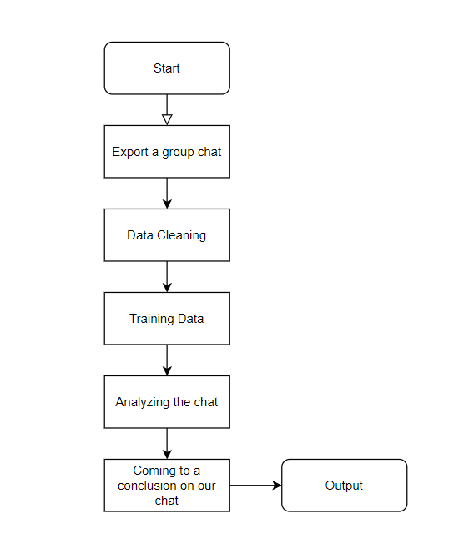

Fig-3.1

Figure 3.1 shows the system design of our group chat analysis project

**CHAPTER - 4**

**SYSTEM SPECIFICATIONS**

**4.1 Software requirements**

* An OS that supports python
* System with 8GB RAM
* System that contains any python compiler and required python libraries.

**CHAPTER – 5**

**SYSTEM IMPLEMENTATION**

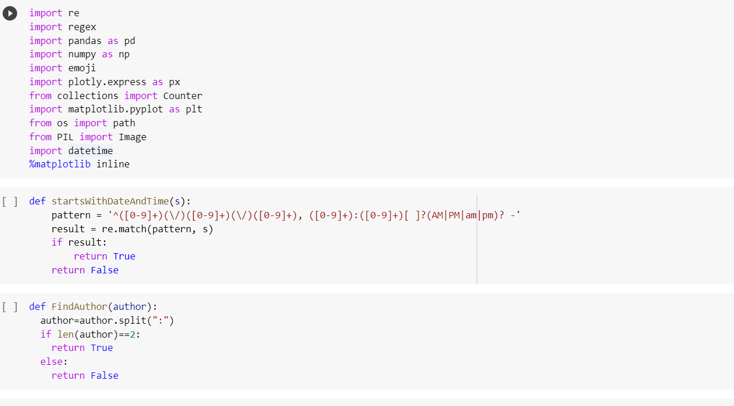

Fig-5.1

Fig 5.1 show the pre processing of the data and to import all the required libraries

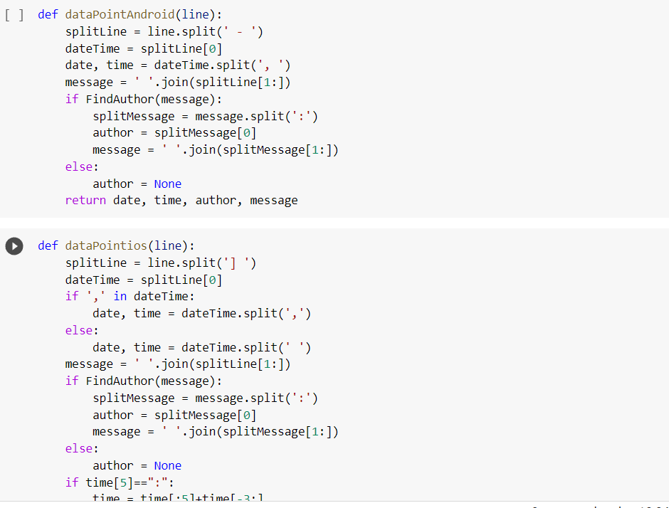

Fig-5.2

Fig 5.2 It shows the pre processing of the data like tokenization of the sentences for android and ios chat.

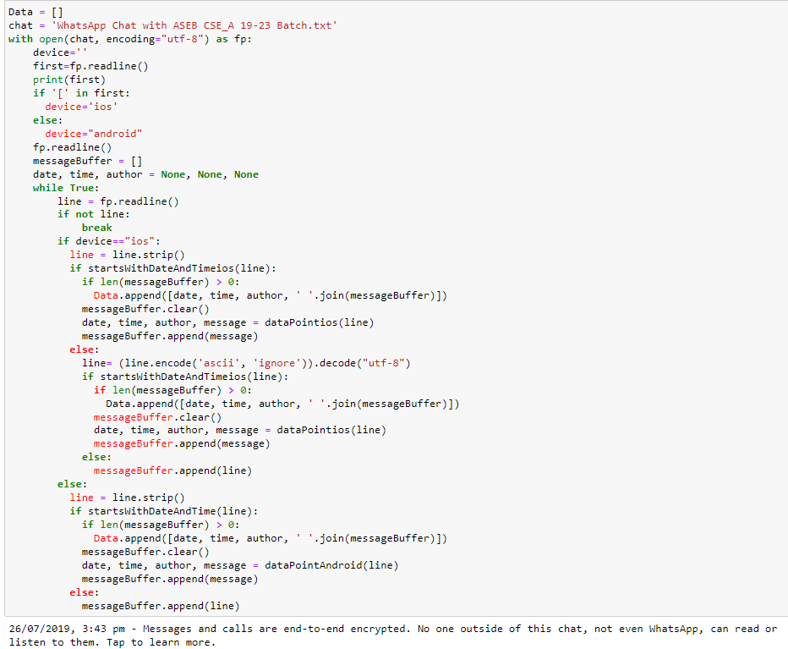

Fig-5.3

Fig 5.3 It reads our data set for the processing.

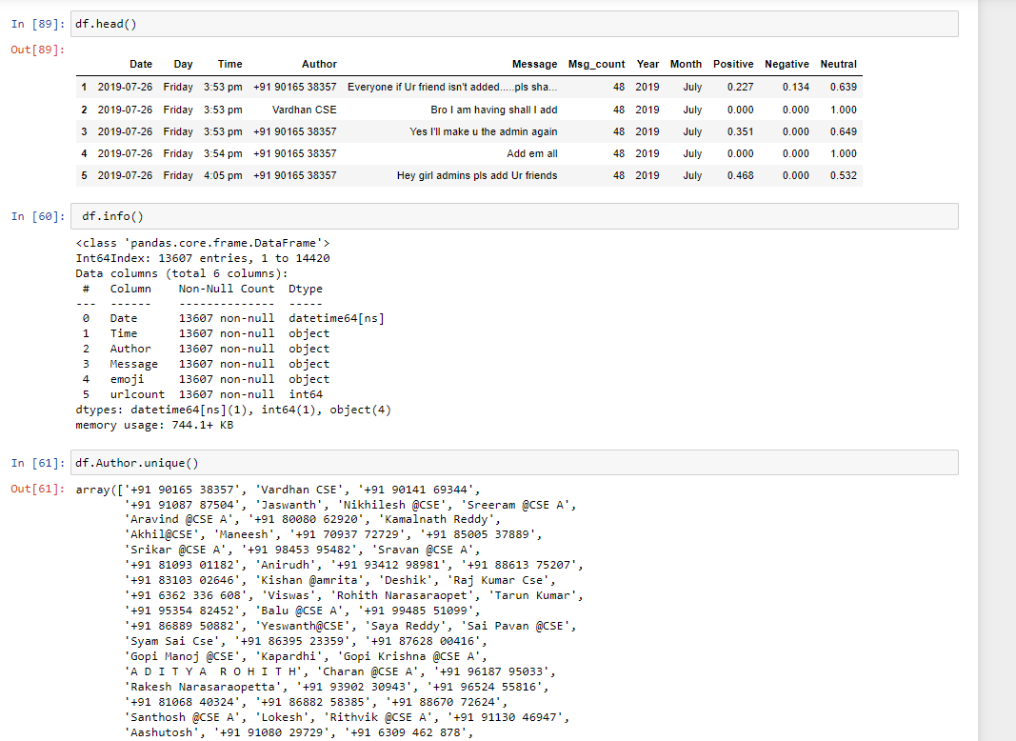

Fig-5.4

Fig 5.4 Displays the data taken from the dataset and also displays the unique authors.

**CHAPTER - 6**

**SYSTEM TESTING**

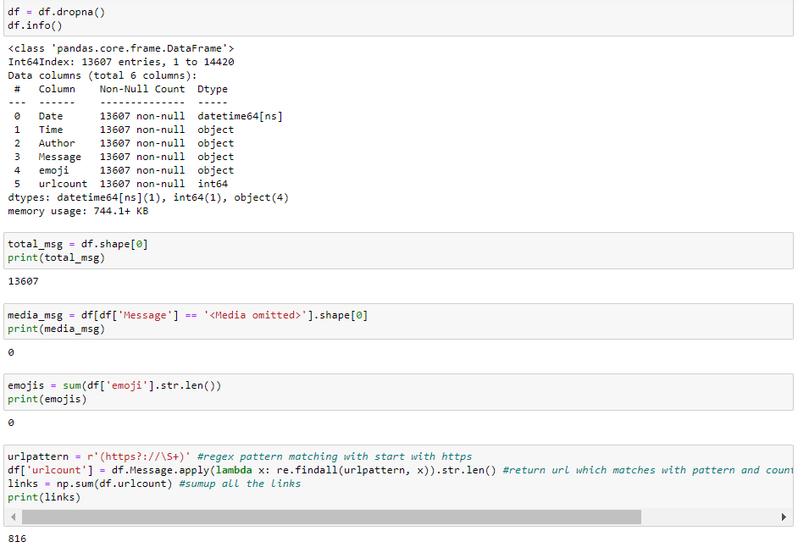

Fig -6.1

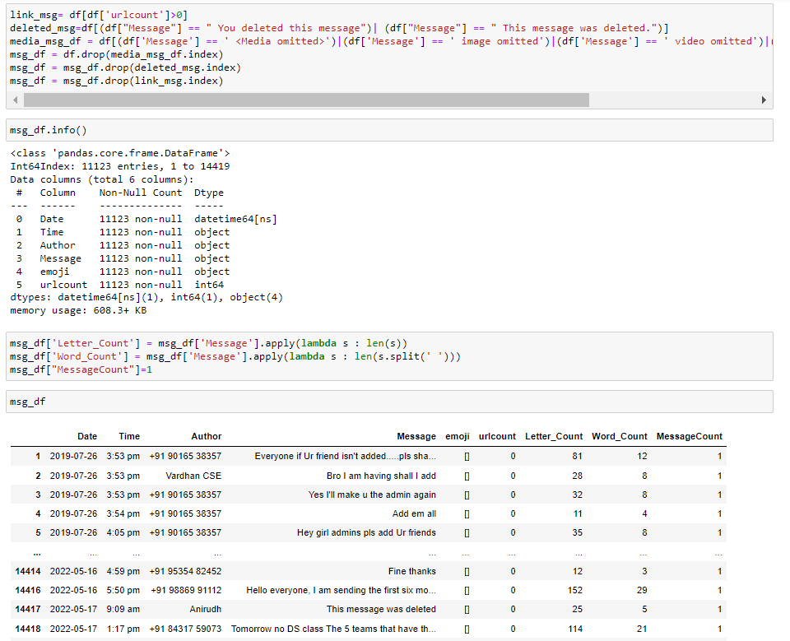

Fig- 6.2

Fig 6.1 and 6.2 shows the working of the data like counting number of messages and droping the null values.

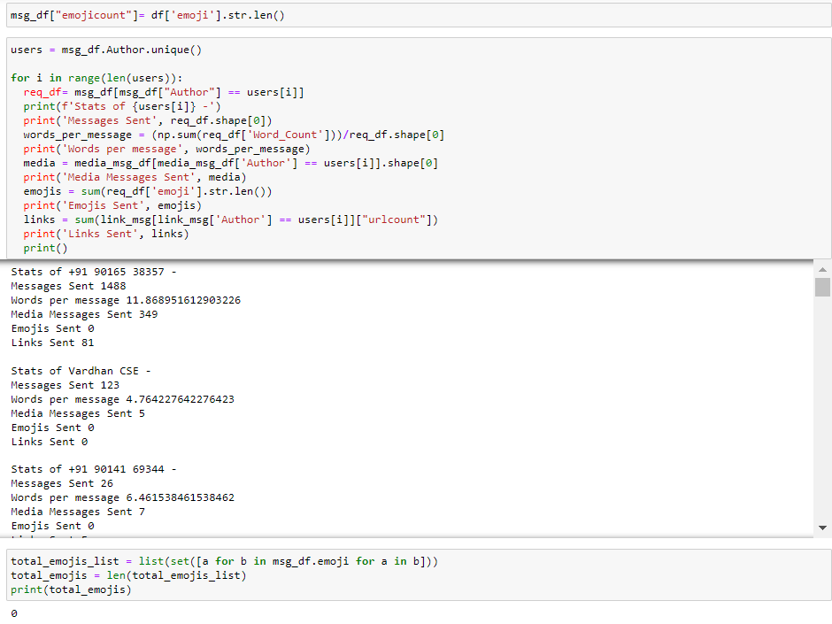

Fig – 6.3

Fig 6.3 Shows the analysis of the group chat based on the author.

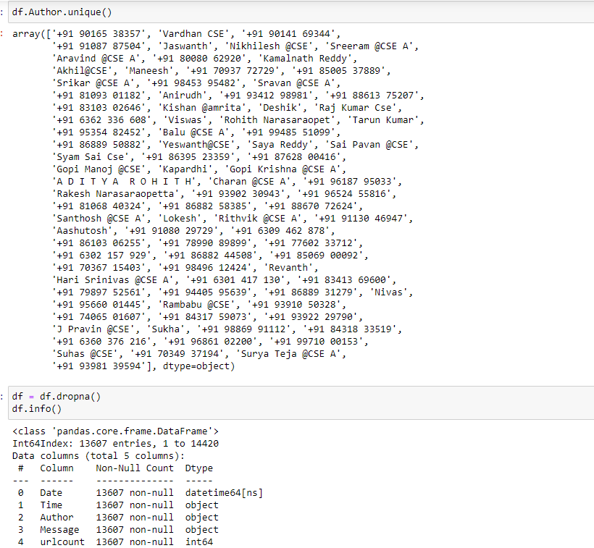

Fig – 6.4

Fig 6.4 shows the total no of authors and total number of messages in the chat after removing the null values.

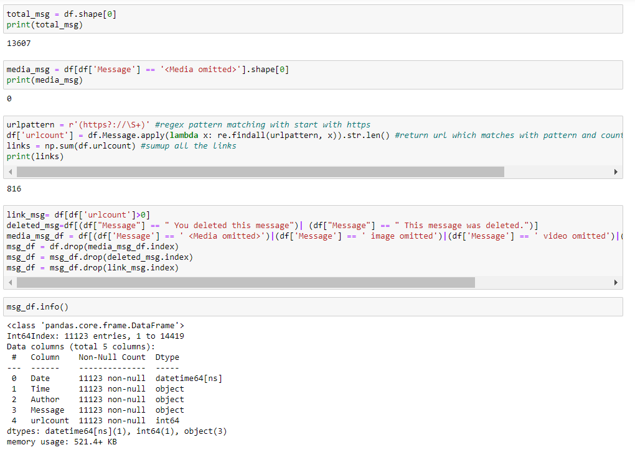

Fig – 6.5

Fig 6.5 shows the number of url count in the group chat and shows the count of the chat after removing url’s count from the total chat count.

**CHAPTER – 7**

**RESULTS AND ANALYSIS**

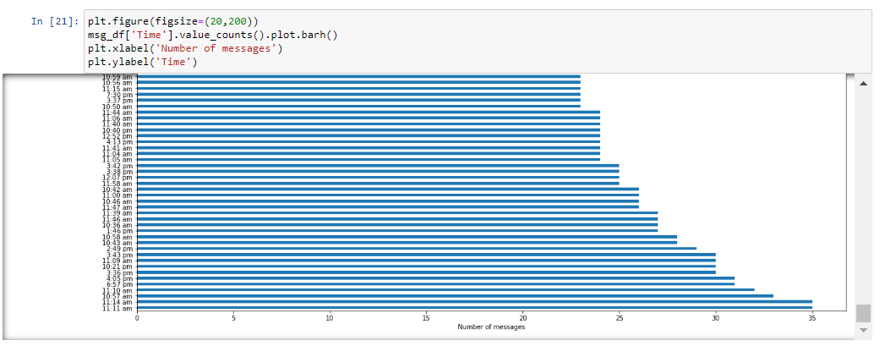

Fig – 7.1

Fig – 7.1 Shows the bar graph based on the number of messages on a particular Time.

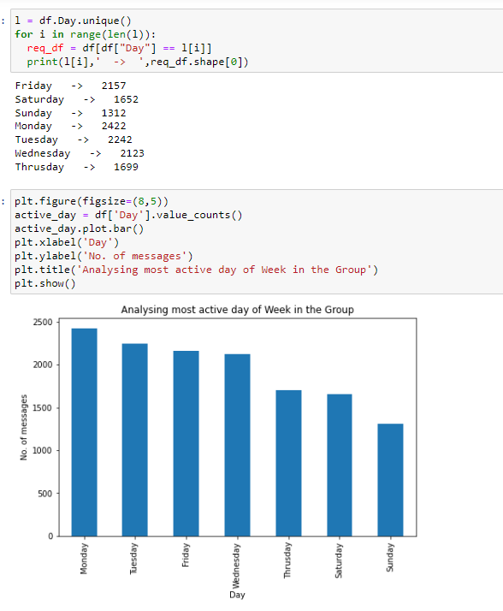

Fig – 7.2

Fig – 7.2 Shows the bar graph representation of number of messages on a particular day of a week.

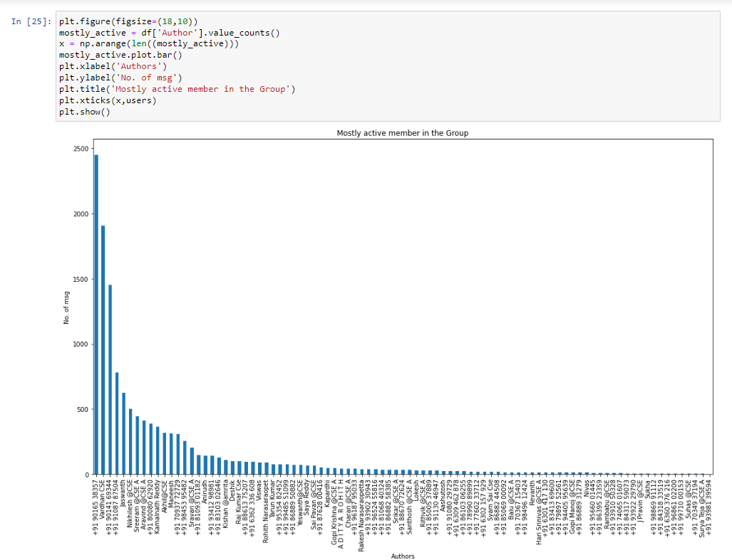

Fig – 7.3

Fig – 7.3 Shows the number of messages by a particular author.

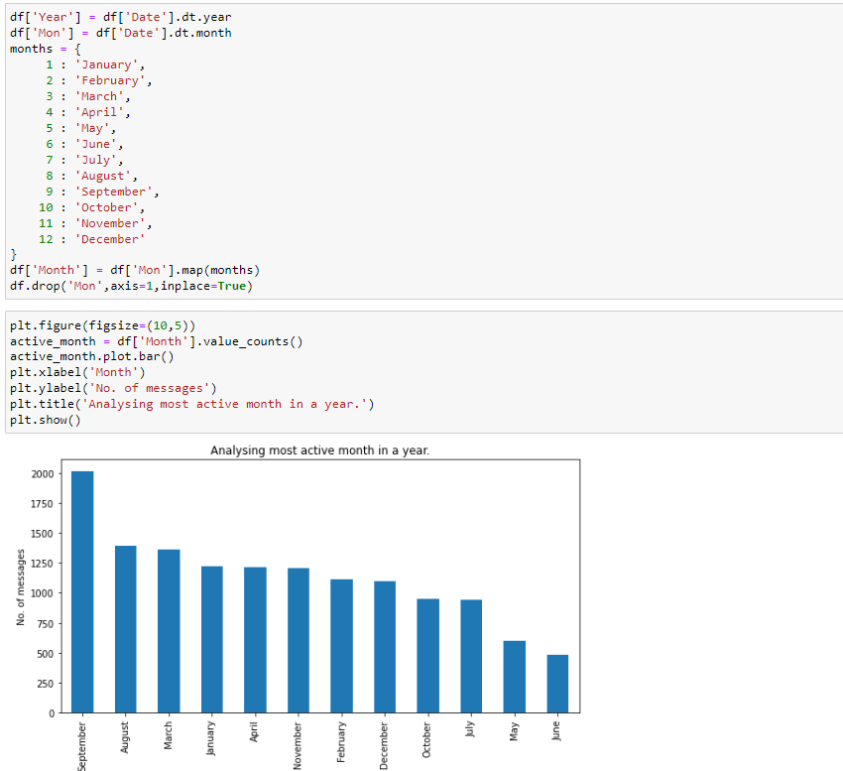

Fig – 7.4

Fig 7.4 shows the bar graph of highest number of messages on a particular month.

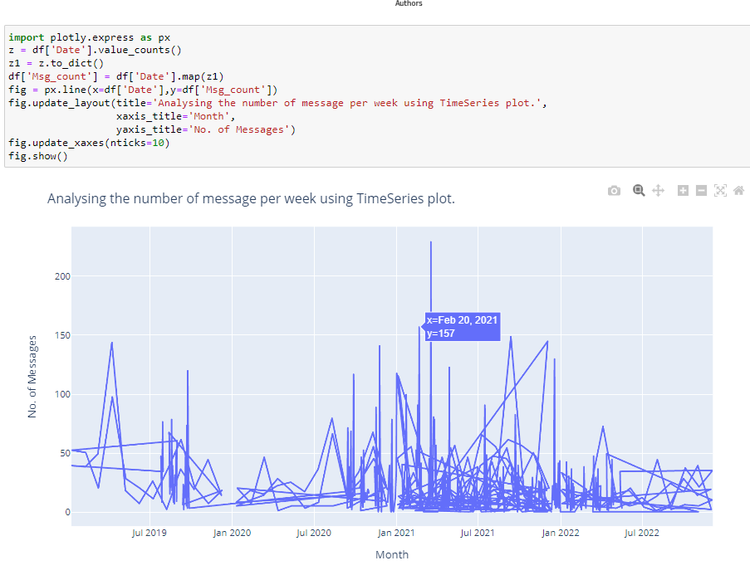

Fig – 7.5

Fig – 7.5 Shows the timeseries plot of the group chat. It shows the no of messages on a particular day.

**CHAPTER – 8**

**CONCLUSION AND FUTURE SCOPE**

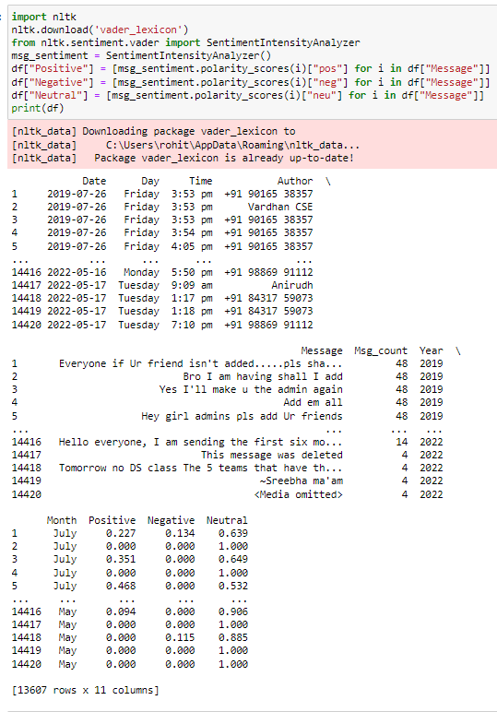

Fig – 8.1

Fig – 8.1 Shows the training the data for finding the chat was whether positive or neutral or negative

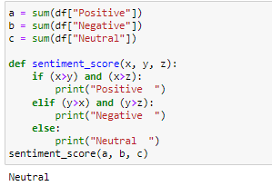

Fig – 8.2

As if we see the fig 8.2 we can say that our chat was neutral.

* This work was able to discuss the WhatsApp application and its libraries, to create an analysis of a WhatsApp group chat and visually represent the top 10 and top 20 users in the chat groups.
* A pseudocode of the plot was given and at the end, visual representation of the plot was implemented.

**FUTURE SCOPE**

* In future the group chat analysis has a lot’s of demand like now days there are many crimes are happening by using this group chat analyzer the police department can find the intruder.
* And also when ever they need to find an intruder or fraud person in a group chat the cyber time can easily find the person easily using the group chat analyzer.

**REFERENCES**

* https://www.ijeat.org/wpcontent/uploads/papers/v9i5/E9578069520.pdf
* http://indusedu.org/pdfs/IJREISS/IJREISS_3661_55346.pd